Instruction

Open the spreadsheet, select your dataset and read it into R:

|  |  |
| --- | --- |
| (i). Produce a time series plot of your data and comment. | 5 mrks |
| (ii).Fit a set of models for your data, and select the best fitting model, saying why you chose this model as the best fitting model. | 8 mrks |
| (iii). Produce diagnostic plots for your models and comment | 5 mrks |
| (iv). Write down the mathematical equation of your chosen model | 3 mrks |
| (v). Produce a 3 step ahead forecast with prediction interval. | 3 mrks |

**Part (i): Plot of Time Series** – Both are same one with month the other Years>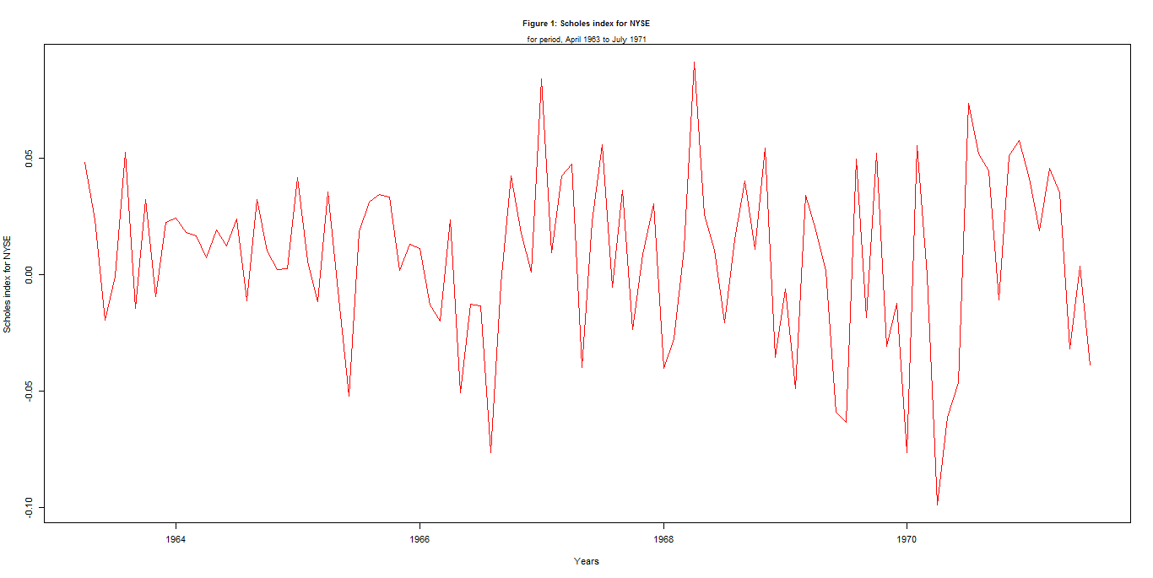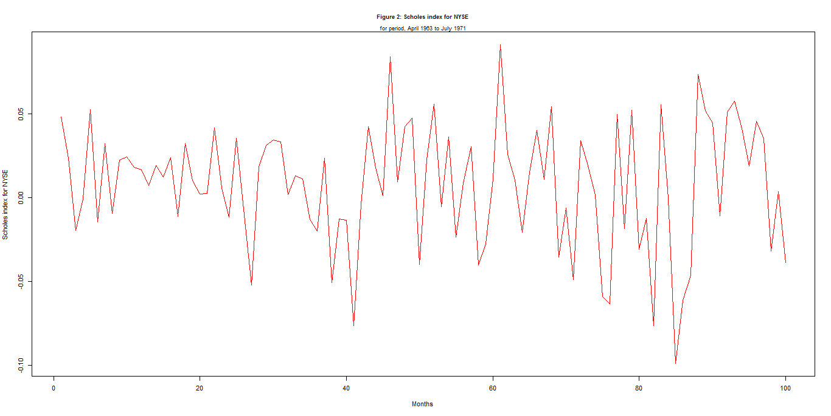

**Comments:**

* No Visible Trend
* No Visible Seasonal pattern
* Large dip at the 85th month of so.
* Increase in Variance. That is months 0 – 40 variation is smaller than 40-100.
  + The Scatterplot below highlights the change in variation better.
  + 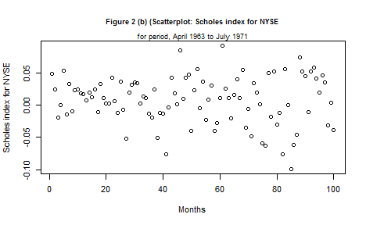
* Due to the Non-Constant Variance we apply a Box-Cox Transformation to stabilize the Variance:
  + 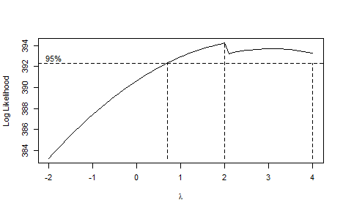
  + Box-Cox Plot implies lamba value = 2. Thus we apply transformation.
* **Transformed Model:**
* 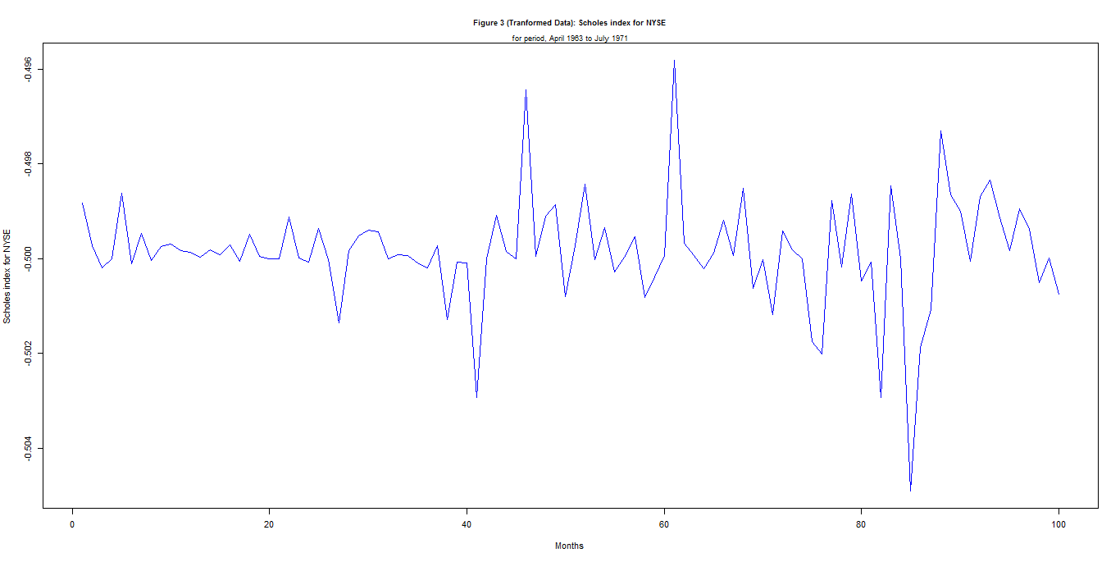
* Comments: Possible pronounce outliers at month 84 or 85 (check data) and 44 and 61.
  + Variation seems to be stabilized
  + No Visible Trend
  + No Visible Seasonal pattern – Thus No differencing required

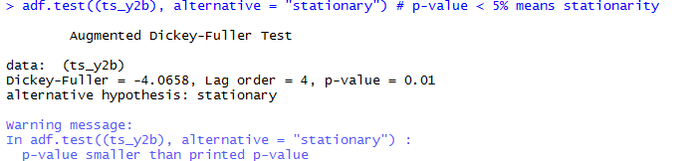

************** &**********

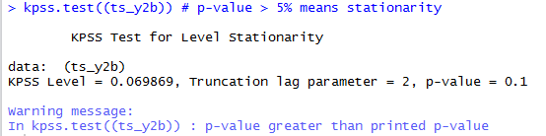

* + Both above Test done in R imply the above time series is stationary.

**Part ii- Fitting a Model**

ACF – Implies a MA(1) process

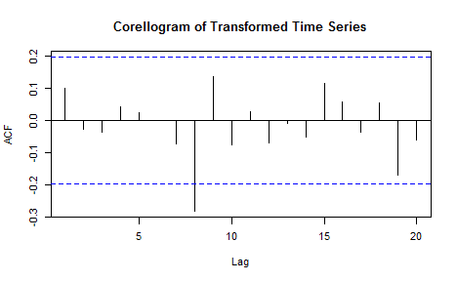

PACF – AR(1)

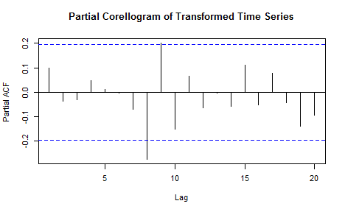

Family or set of models fitted to our data:

* ARIMA(1,0,1):
* 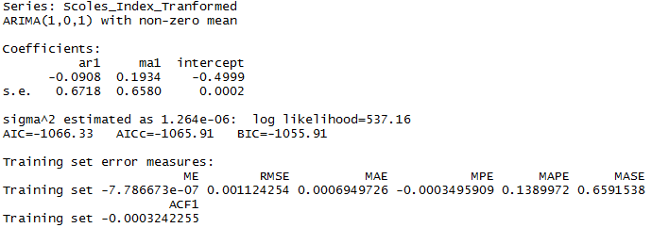
* ARIMA(1,0,0):
* 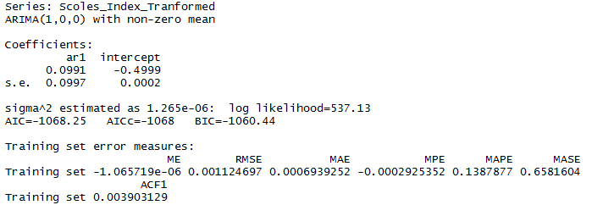
* ARIMA(0,0,1):
* 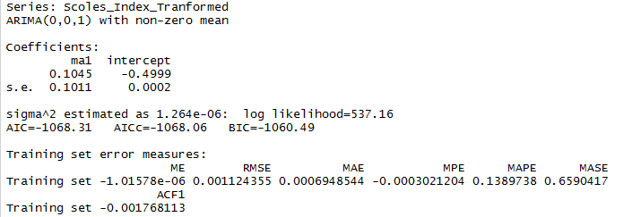
* ARIMA(0,0,0)
* 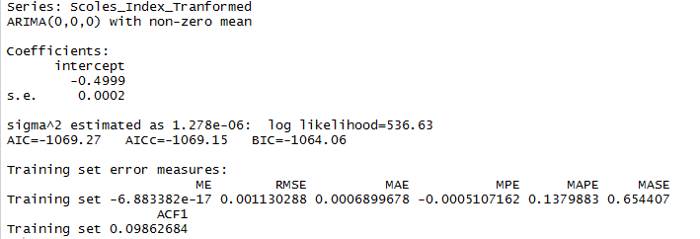

Using the Principle of Parsimony we choose a model.